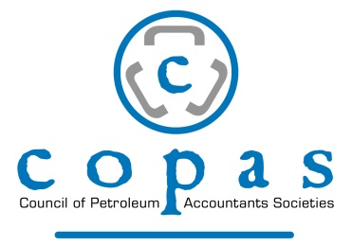

COUNCIL OF PETROLEUM ACCOUNTANTS SOCIETY OF ACADIANA
PO BOX 51925
LAFAYETTE, LA 70505-3266

2018-2019 Officers:

Tom Elliott & Alex Gray, Co-President
Judith Faulk, Vice President
Charlotte Bordelon, Secretary
Danielle Landry, Treasurer
Daryl Monju, Joint Interest Liaison

APPLICATION FOR MEMBERSHIP

APPLICANT’S NAME: _______________________________________________________________

EMPLOYER NAME: _________________________________________________________________

EMPLOYER ADDRESS: ______________________________________________________________

POSITION: _________________________________________________________________________

NATURE OF WORK: ________________________________________________________________

E-MAIL ADDRESS: __________________________________________________________________

ALTERNATIVE E-MAIL ADDRESS: _____________________________________________________

HOME ADDRESS: ___________________________________________________________________

PHONE: ______________________________

ALTERNATIVE PHONE: ______________________________

MEETING TOPIC RECOMMENDATION(S): _______________________________

PLEASE ENCLOSE CURRENT YEAR DUES IN THE AMOUNT OF 250.00 FOR MEMBERSHIP AND MEETING FEES FOR THE ENTIRE YEAR.

APPLICANT’S SIGNATURE: __________________________________ DATE: ___________________

